PPG NewsLetter
Autumn/Winter 2019: Edition 9

Seasonal Greetings
To All

Friday 20th December: 8.00 – 6.30pm
Saturday 21st December: Closed
Sunday 22nd December: Closed
Monday 23rd December: 8.00 – 6.30pm
Tuesday 24th December: 8.00 – 6.30pm
Wednesday 25th December: Closed
Thursday 26th December: Closed
Friday 27th December: 8.00-6.30pm
Saturday 28th December: Closed
Sunday 29th December: Closed
Monday 30th December: 8.00-6.30pm Tuesday 31st December: 8.00-6.30pm
Wednesday 1st January: Closed
Thursday 2nd January: 8.00-6.30pm
The benefits of using Patient Access: -
- Everything is done on line via a computer or a mobile app
- Your repeat prescription can be ordered online so that it is ready for you to pick up from the surgery or you can ask for it to be sent straight to a pharmacy of your choice
- You can pre book on line appointments- non urgent
- Message the GP with health issues - non urgent
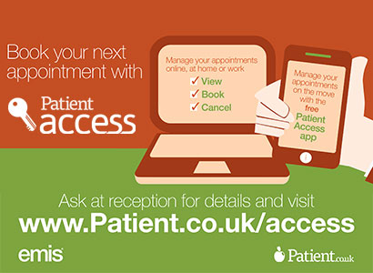
- View some of your medical notes on line

To sign up for Patient Access please contact reception and they will give you the relevant forms and more information.
Important notice to all patients:
Please make sure that you keep all your details up to date
These include:
* Phone Number
* Address if you move house
* Email address if appropriate
* Change of name
* Anything else you think the practice may need to know
You will be required to produce identification for a change of address such as a recent utility bill at your new address

SEASONAL FLU
Flu (also known as influenza) is a highly infectious illness caused by the flu virus. It spreads rapidly through small droplets coughed or sneezed into the air by an infected person.

For most people, flu is unpleasant but not serious. You will usually recover within a week. Studies have shown that flu vaccines provide effective protection against the flu, although protection on may not be complete and may vary between people. Protection from the vaccine gradually decreases and flu strains change over time. Therefore, new vaccines are made each year and people at risk of flu are encouraged to be vaccinated every year.
Who should have the flu jab?
The injected flu vaccine is offered free of charge on the NHS to people who are at risk. You are eligible to receive a free flu jab if you:
- Are 65 years of age or over
- Are pregnant
- Have certain medical conditions
- Are very overweight
- Are living in a long-stay residential care home or other long-stay care facility
- Receive a carer’s allowance, or you are the main carer for an elderly or disabled person
- Are a healthcare worker with direct patient contact, or a social care worker
APPOINTMENT SITUATION
Demand for appointments has escalated to an unprecedented high level. So please help me to help you by sharing the reason for your call with the reception team. This will avoid you from having to call back again and again for an appointment. If you share the reasons then you will be guaranteed treatment on the same day!

Introducing Walking Football  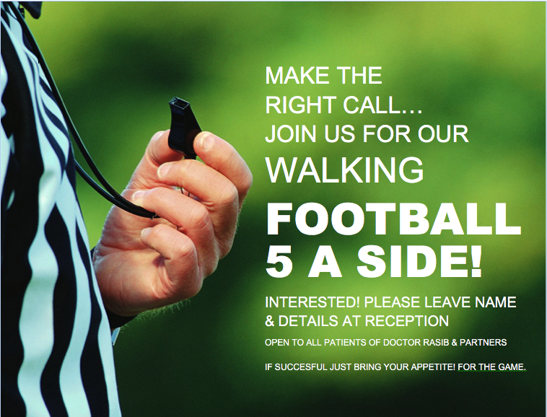  Please get involved  PATIENT QUESTIONNAIRES  Please get involved with the patient surveys which will be handed out by our PPG members between September – December – it is important that we hear and receive feedback from our patients  Health & Wellbeing  Just give a thought!  Enjoy your celebrations through the festive season, the food and drink you will enjoy, just give the same thought to your care of health and wellbeing.  FLU & PNEUMO VACCINATIONS  FLU JAB! Don’t Come Down With The Flu, Come Down Here For The Flu JAB!  PLEASE BOOK AT RECEPTION  PPG (PATIENT PARTICIPATION GROUP)  Our PPG continues to be a valuable source of information and support for the Practice team.  If you are interested in joining the PPG, please speak to the reception team. | Emergency & OOH Cover  EMERGENCIES  In the event of a serious problem, such as chest pain or collapse, call 999 immediately.  OUT-OF-HOURS COVER  Medical advice is always available for emergencies at night, weekends and  all bank holidays.  NHS 111  For urgent  & non-urgent advice call 111.  You can also ring  01543 576660  where the recorded message will give you the number for the Out-of-Hours service  STOP PRESS!  !!! DO NOT FORGET TO ALLOW 48 HOURS FOR YOUR REPEAT PRESCRIPTIONS !!!
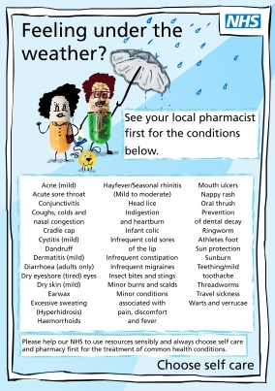
IMPORTANT NOTICE
Prescribing Local Improvement Scheme:
We need to reduce what is being prescribed to patients on prescriptions as part of a new Scheme. The practice will need to meet the following objectives:
- Containing growth in prescribing expenditure
- Reducing expenditure on drugs that are prescribed for conditions that can be managed through self-care (OTC)
In line with the new UK five-year action plan for tackling antimicrobial resistance practices to continue prescribing antibiotics prudently.

We welcome a Nurse Prescriber at the Practice
Most patients will be familiar with Hannah Tranter who has been working at the practice as a Practice Nurse for a number of years. We are pleased to announce that Hannah successfully completed her prescribing course recently and is now working as a Nurse Prescriber.
Introduction of
Nutritionist Clinics

A nutritionist service is being offered at the practice by a trained nutritionist
Daniel Jakeman. If you require any help or advice then please ask a member of the reception team who will happily book you into one of the clinics being offered at the practice.
MAC Clinical Research Remote Tablet and APP for patient self-referral:

The Remote tablet is being made available
at the practice for
Patient’s to be able
To self refer, giving
them the
opportunity to
know what trials
are going on in
the local area
Introduction of Physical Activity Instructor & seated exercise classes for our patients at the practice:

A Physical Activity Instructor (Alex Clay)
has joined the team so that a Full free
Weight management service can be offered
to eligible patients. This will be a free
45-minute activity class (chair based
exercise or low impact circuits depending
on the abilities of the group). The idea is
to introduce the physical activity alongside
the nutrition class in order for patients
to receive full support, and further support their
weight loss goals.
Please ask at reception for more details.

Disclaimer: This newsletter is produced by the PPG group in partnership with the practice management team. Some articles written by PPG members are of their ideas, facts or opinions and therefore will not be the responsibility of the surgery. If you have any queries then please fell free to contact the PPG Chairman, David Stagg by phone: 07549 021316

‘SEASONAL NEW YEAR GREETINGS TO ALL’

If you require this leaflet in any other format then please do not hesitate to speak to a member of the team.

If you have any comments or suggestions about this newsletter or indeed any aspect of the service that Dr Rasib & Partners provides, please feel free to contact the Managing Partner, Sam Rasib on 01543 576660 or in writing to GP Suite, Cannock Chase Hospital, Brunswick Road, WS11 5XY

